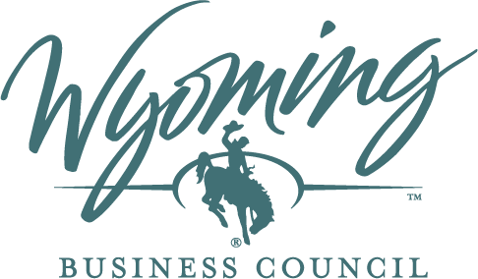

Wyoming Broadband Office
BEAD Program

Euna Post-Award Guide

May 2026

Table of Contents
Introduction 2
Getting Started 3
How To Log in to the Portal 3
How To Add a New User 3
How To Contact Wyoming Broadband Office for Assistance 5
Reporting 5
Payment Requests 6
How to Create a New Payment Request 6
How to Complete the Payment Request 7
How to Cure a Payment Request 11
Euna Resources 12

Introduction
This guide provides instructions for Wyoming Broadband Equity, Access, and Deployment (BEAD) Program subgrantees to complete required post-award tasks within the Wyoming Broadband Office BEAD grants portal. Wyoming uses Euna Grants powered by Euna (“AmpliFund”) as its grants management system.
The guide is intended to assist subgrantees in navigating the portal. For questions about your award, compliance, reimbursement, and other issues, email Chad Bolling, Broadband Manager with the Wyoming Broadband Office at chad.bolling@wyo.gov. For technical assistance, email GMSAssist@ctcnet.us.

Getting Started

How To Log in to the Portal
If you have not created an account, you will receive an email inviting you to join your organization in Euna.
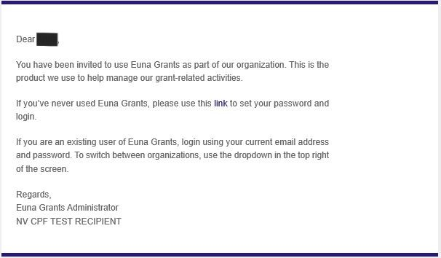
Click the link in the email and create your password on the landing page.
Once you have created an account, you may log in to the portal.
- Go to gotomygrants.com.
- In the login window, enter your email and password.
- Click Login.

How To Add a New User
You can add a new user to Euna in the Administration module.
- Open Administration > System Security > Users.
- Click the + (Create Icon) in the Icon Bar.
- Under User Information, select if the new user will subscribe to daily emails and/or subscribe to weekly emails. Once the user activates their account, they can update their email subscription preferences.
- Select the user’s department (optional). This list pulls from Administration > System Security > Departments.
Note: Depending on your Euna account type, you may have different Record Types available to you.
Under the Security section, you will assign the user’s role by setting their access level for your organization’s Object Types. “Object Types” are elements within Euna that represent different types of data a user will interact with, such as grant applications, budgets, and custom forms.
- Select the Object Type:
  - Account: Account access will apply to all Record Types. All Account users will have access to all areas of the account, including Administration. Account Admin are the only users who can create and delete user records and can act as other users.
  - Departments (all records linked to departments): This includes any records that are linked to the user’s department, which could include awards, funds, grants, opportunities, or projects.
  - Grants: This includes all grants that your organization has received, as well as any grant opportunities or subawards.
- Select the Access level for each Object Type that you choose:
  - Admin: The user can view, create, edit, and delete records; can add progress against a record and collaborate; and has access to Administration areas.
  - Editor: The user can view and edit records (but cannot create or delete); and can add progress against a record and collaborate.
  - User: The user can view record details (but cannot create, edit, or delete); and can add progress against a record and collaborate.
  - View Only: The user can view a record only (but cannot create, edit, delete, add progress, or collaborate).
- Select any account-wide restrictions for the new user under Advance Restrictions. If you select one or all these restrictions, the new user will not be able to view or access restricted content, regardless of any other role or permission. You can select from the following restrictions:
  - Approvals: The user cannot approve or reject records including payment requests, payment authorizations, or amendments.
  - Budget: The user cannot access budget or expense data.
  - Payment Authorizations: The user cannot create or edit payment authorizations, but can view them.
  - Post-Award: The user cannot access any post-award data.
  - Salary: The user cannot access any salary data.
Finish creating the user by adding the user information in the fields displayed.
- In the Status dropdown, select Enabled.
- Click Create.
- Send an invitation email to new users by clicking the envelope icon next to the user’s display name.
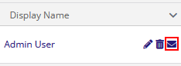
Note: Euna login usernames (i.e., the user’s email address) cannot be edited in the system. However, you can update a user’s primary email address as necessary. If you need to change the Euna username, email Chad Bolling, Broadband Manager with the Wyoming Broadband Office at chad.bolling@wyo.gov for assistance.

How To Contact Wyoming Broadband Office for Assistance
For questions related to the functionality of the portal, your award, compliance, reimbursement, or any other issues, email chad.bolling@wyo.gov. For technical assistance, email GMSAssist@ctcnet.us.

Reporting
You will follow the same process in Euna to submit all required reports and forms.
- From the landing page, click on Grant Management, and then “Grants” in the dropdown.
- Click on your award to enter the Award Details page.
- From the top row, open Custom and select from the dropdown the report or other form you are submitting.
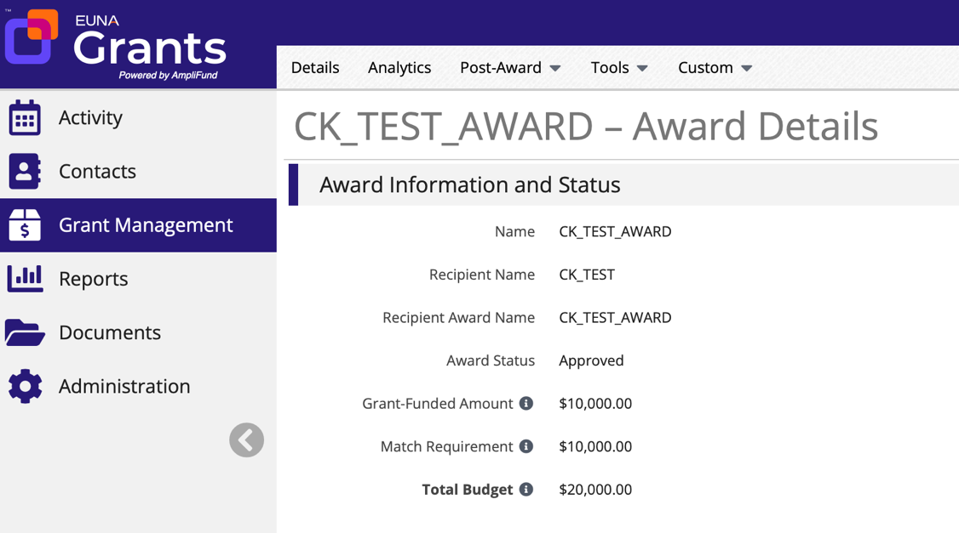
- Click on the + (Create Icon) in the top right to create a new form.
- Answer the questions, paying close attention to the directions. Depending on your answer to certain questions, you may not need to answer questions that follow; the question language will instruct you whether an answer is required. Questions that are required for all subrecipients are indicated with an asterisk. You may be required to answer additional questions that are not marked with an asterisk if they apply to you.
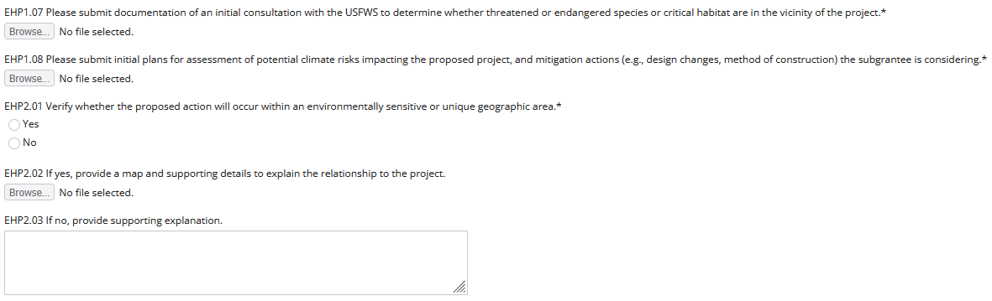
- If you would like to save your progress, click on “Save as Draft.” At this point, your form is saved, and you can return at a later point to finish the form.
- When the form is complete, click “Submit.”
  - Once you click Submit, you cannot make changes to the report.
  - If a report you submit requires curing, the Wyoming Broadband Office will contact you with instructions on what to cure and reopen the report in Euna.
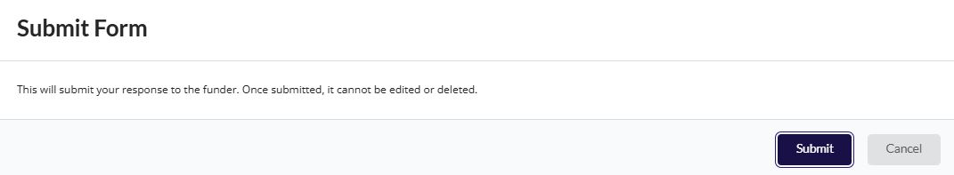

Payment Requests
Subgrantees will submit payment requests based on the completion of milestones as specified in their grant agreement. Subrecipients may only request payment for a completed milestone, and can include multiple milestones within one payment request.

How to Create a New Payment Request
- Log in to Euna. From the landing page, click on Grant Management and then click Grants in the dropdown.
- Click on the award for which you are adding a payment request to enter the Award Details page.
- From the top navigation bar, open Post-Award > Cash Flow > Payment Requests.
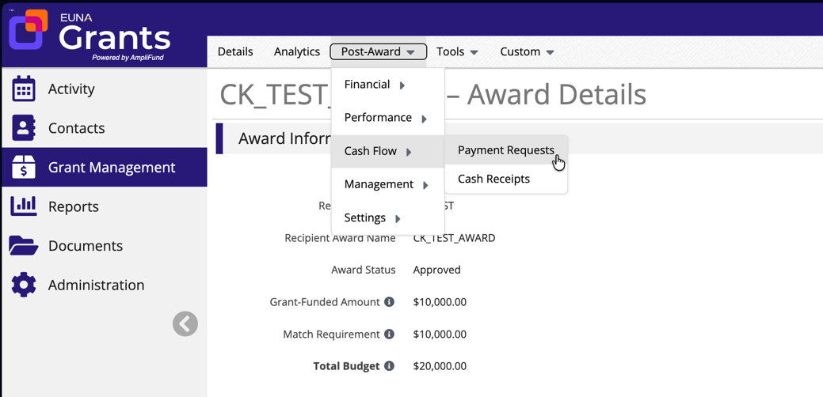
- Click on the + (Create Icon) in the top right to create a new payment request.
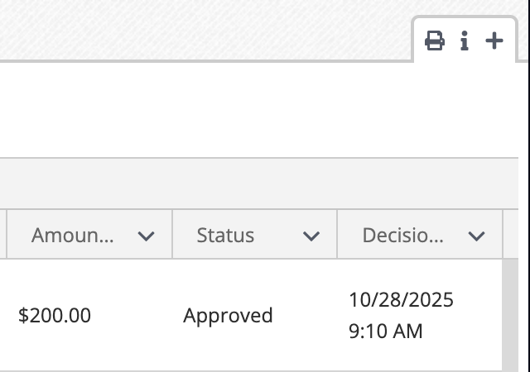

How to Complete the Payment Request
- Confirm the Funder Organization and Grant Name.
- Enter a Payment Request Name in the following format: [Award Number] – [Milestone(s) for which you are submitting the payment request].
- Leave the Date Created field as is.
  - This field automatically populates with the date the payment request is opened.
- To set the expense range, select the beginning and end dates milestones were reached for this payment request as “"Expenses From and Expenses To”.
  - Important Considerations:
    - Euna uses the term "Expense(s)" to reference the item(s) Euna uses for the item(s) used to populate payment requests. Under the BEAD program’s milestone disbursement model, subgrantees will not submit itemized costs as “Expense(s)” but rather the amount they are requesting for disbursement for each milestone as defined in their contract.
    - When you create the expense(s) for the milestone(s) in this request (described below), the expense date(s) must fall within this date range to be associated with the milestone disbursement request. Ensure you set the range accordingly.
- Do not change the Payment Type.
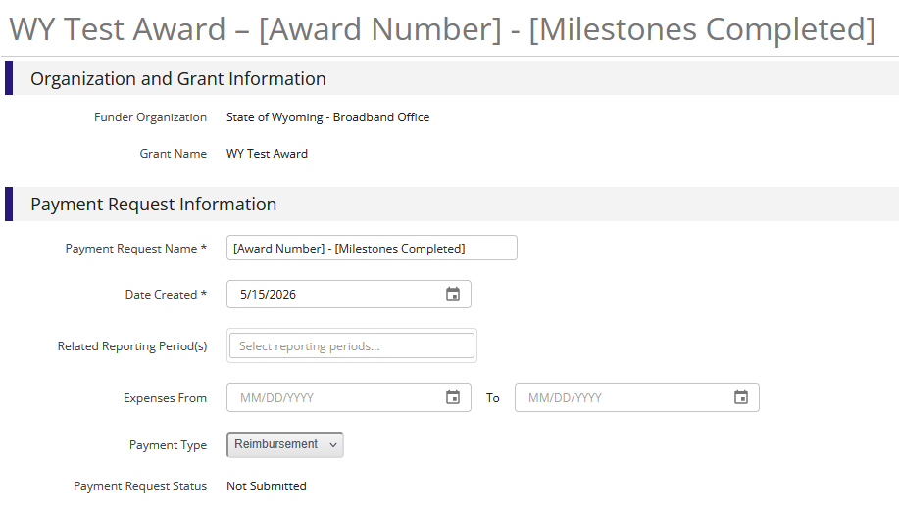
- Click on Create New Expense. This will open a form with three tabs.
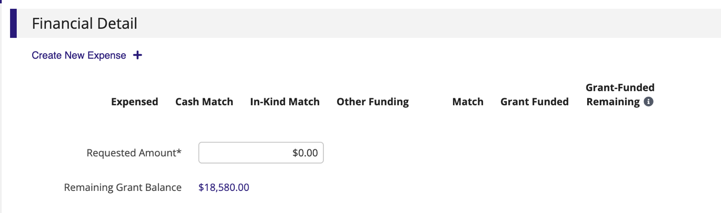
  - In the General tab:
    - For the budget Category, select the milestone for which you are submitting the payment request.
      - If you are including multiple milestones within the payment request, create one expense for each milestone.
    - Select the budget Line Item.
    - Enter the Direct Cost of the expense.
      - For the Direct Cost, enter the total amount to be disbursed at the completion of the milestone in question.
      - Only create one expense per milestone.
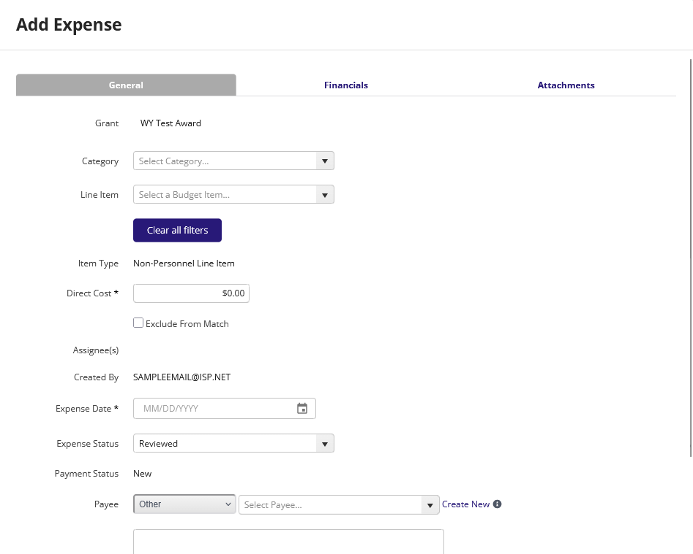
    - Enter the Expense Date.
      - The Expense Date must be within the expense range for the payment request you set above. If the Expense Date falls outside that date range, the expense will not be pulled into the payment request.
    - Leave the expense status as "Reviewed.”
      - Note: Only expenses with a status of “Reviewed” will be associated with the payment request.
    - Leave the Payee section as is (shown below.)
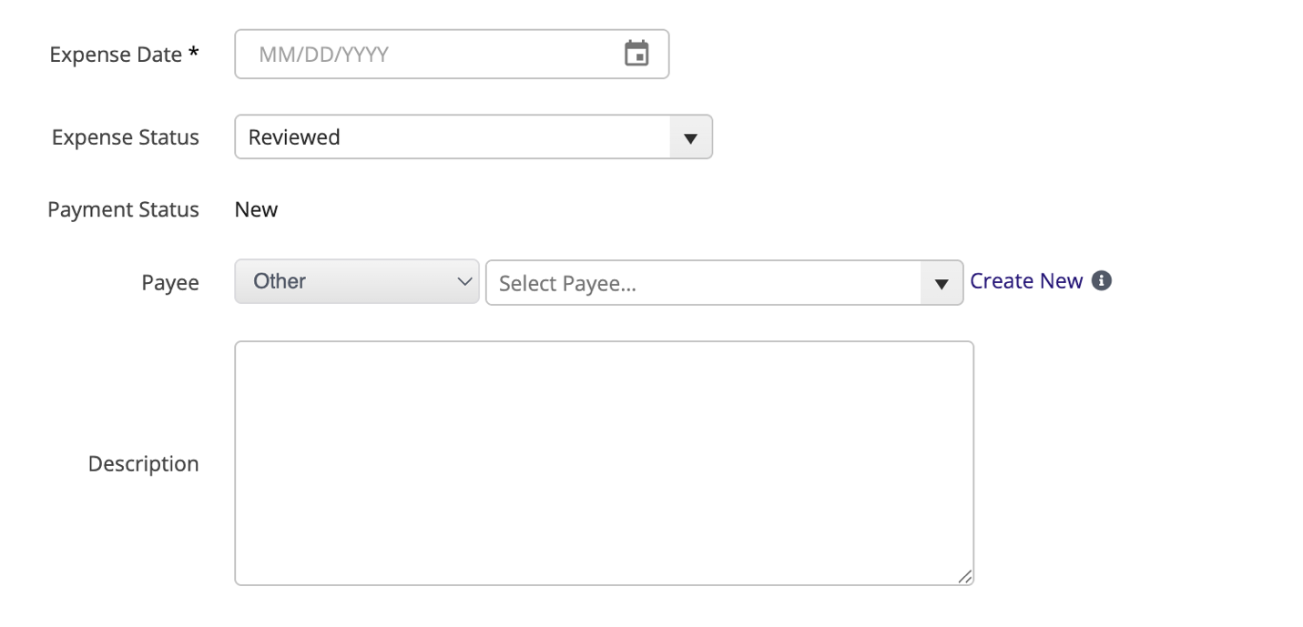
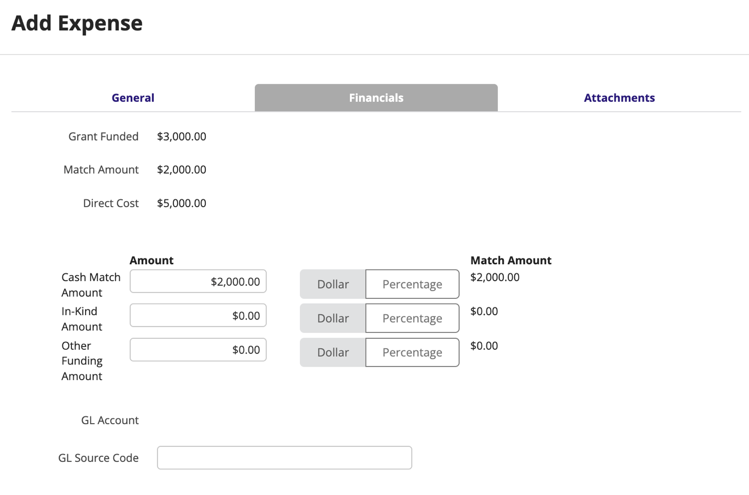
  - In the Attachments tab:
    - Upload invoices and proof of payment for the expense.
    - Note that any other documentation required for the milestone by your grant agreement will be uploaded separately in the Additional Evidence section below.
  - Select Create to finalize the expense.
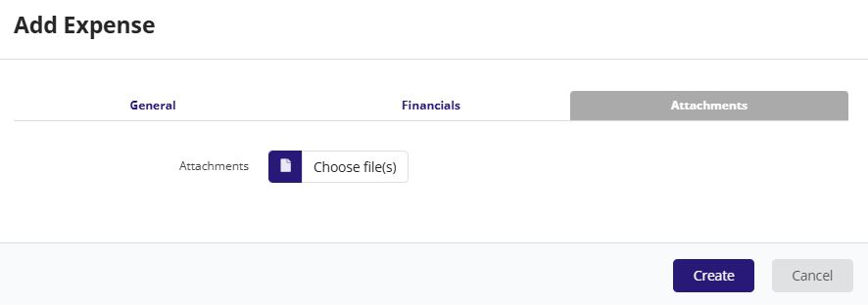
- A table will automatically populate on the Payment Request page with your expense information.
- Once you have entered your expense(s), copy the Total from the last row of the Grant Funded column in the table and paste it into the Requested Amount field below.
  - This is the amount you are requesting for reimbursement from the Wyoming Broadband Office.
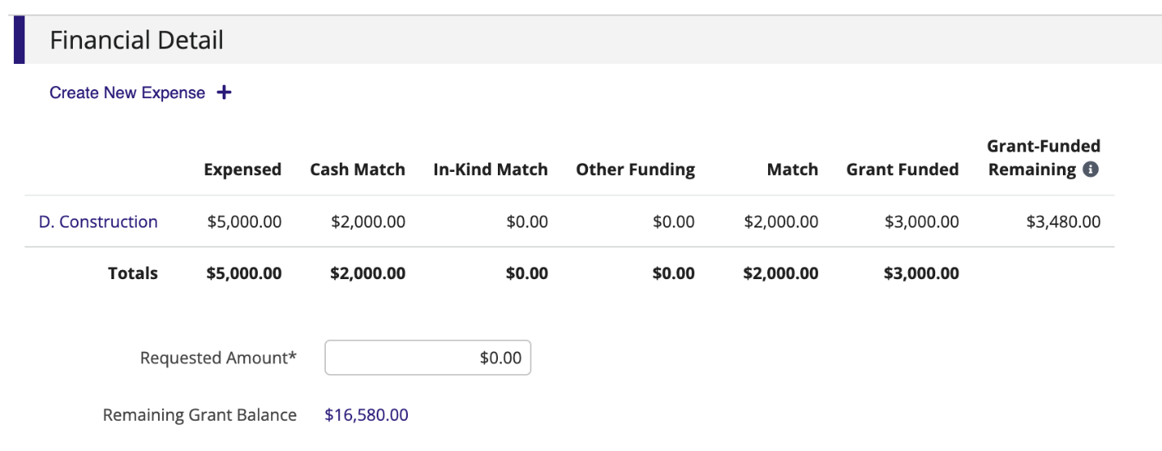
- Scroll to the Additional Evidence section at the bottom of the page. If your grant agreement requires any documentation for the milestone(s), such as engineering information, upload that information where prompted under Additional Evidence.
- Enter any applicable comments under the Additional Information section in the Comments field. (This step is optional.)
- Click Create to save the payment request.
- Click Submit to send the payment request for approval.
  - Verify the Requested Amount displayed in the pop-up message is correct before clicking Submit in that window.
  - No changes can be made to the payment request after selecting Submit.
- When a payment request is approved, you will receive a notification email from Euna indicating the request is approved.

How to Cure a Payment Request
- If a payment request is rejected, the subgrantee will receive a notification email from Euna indicating that the request was rejected. The request will be reopened in the portal for you to edit, with a comment containing instructions on what to cure.
- Go to the reopened payment request in the portal to view the instructions.
- Edit the request as directed.
- When you are done, click Submit to send the revised payment request for approval.

Euna Resources
- Euna Grants Resources Page (you must create a Zendesk account to access the official Euna Grants resources)
- Euna Grants Video Tutorials (you must create a Zendesk account to access the official video tutorials)
- Applicant Portal User Guide
- Applicant Portal FAQ
- Applicant Portal Terminology Guide

