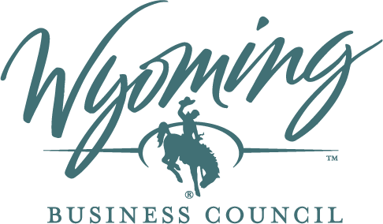

Wyoming Broadband Equity, Access, and Deployment (BEAD) Program

Statement of Work Attachment
Protecting the BEAD Program From Defaults Certification
May 2026
Should additional guidance on required certifications be published, WBO will issue amendments to the Agreement, as needed.

[SUBGRANTEE LETTERHEAD]
Subaward Agreement No.:
Subgrantee:
Project Name:
Protecting the BEAD Program From Defaults Certification
- The Subgrantee certifies that it and any of its affiliates will not require or accept any additional federal funds to support a BEAD project during the BEAD subaward agreement’s period of performance, extended period of performance, or Federal Interest Period.
- The Subgrantee certifies that it and any of its affiliates will not require or accept any additional federal broadband service subsidies for the project(s) and/or Broadband Serviceable Location(s) (BSL(s)) to be served by the subaward during the BEAD subaward agreement’s period of performance, extended period of performance, or Federal Interest Period, other than any such subsidies that were committed prior to the BEAD subaward agreement. This includes, but is not limited to, new operating expenses for any BEAD project(s) or BSL(s).
- The Subgrantee understands that this certification may be published publicly.
Certification
I, the undersigned, am the Authorized Organization Representative (AOR) signing the subgrant agreement on behalf of the Subgrantee, and I have signatory authority for the Subgrantee’s affiliates. I further understand that, if the information provided by my organization to the Department is materially false or my organization fails to comply with the Agreement or complete the Project within the Term, the Department may revoke this Agreement in its entirety and suspend, rescind, and/or recoup payment of the Grant Amount in accordance with this Agreement. To the best of my knowledge, all of the above certifications and assurances are true and correct.
Signature of Subgrantee AOR:
Printed Name:
Date:
Title:
Address:
Telephone:

